Dear York Road Families,

It is hard to believe that this year’s fourth quarter is already well underway! As we approach end-of year testing, please keep the calendar below in mind. Thank you in advance for doing your best to avoid making appointments that would require your students to arrive late, leave early, or be absent on testing days. As always, thank you for your continued support!

**May 2021**

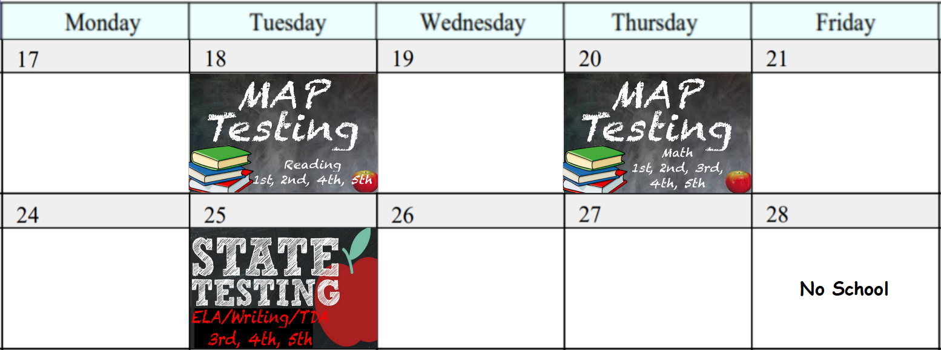

**June 2021**

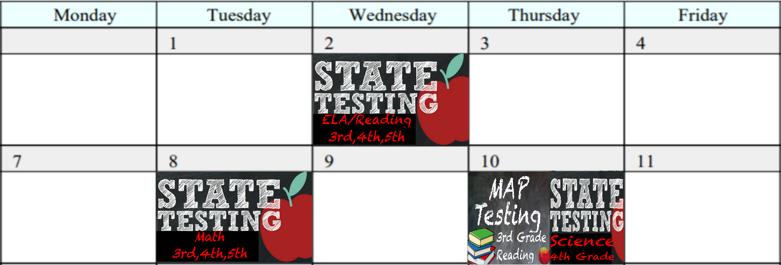

**No School**

**1st Grade:** May 18th & May 20th

**2nd Grade:** May 18th & May 20th

**3rd Grade:** May 20th, May 25th, June 2nd, June 8th, June 10th

**4th Grade:** May 18th, May 20th, May 25th, June 2nd, June 8th, June 10th

**5th Grade:** May 18th, May 20th, May 25th, June 2nd, June 8th